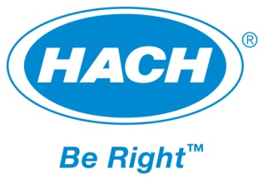
FOR IMMEDIATE RELEASE

Contact: Bard Parnell
970-663-1377 ext. 2493
bparnell@hach.com

Hach WIMSTM, Version 7.5 Brings New Analysis Tools

Loveland, Colo. – (October 8, 2014) – A new version of Hach WIMSTM, Version 7.5, was released on September 26th, 2014. Hach WIMSTM is a software platform that provides easy access and visibility to data from many disparate sources for reporting, analysis and monitoring at water and wastewater utilities,. Hach WIMS provides a wide range of tools to easily generate reports, create useful dashboards, and perform in-depth analysis allowing users to make impactful operational decisions based on real data.

Hach WIMS, Version 7.5 introduces new Statistical Process Analysis (SPC) tools, consisting of new reports and a number of new charts, to help visualize your process to detect outliers, analyze data for predictions and see how parameters influence each other.

- New graphs including Year over Year and Histogram charts
- Correlation analysis tools
- Enhanced root cause analysis

Additionally, the release provides new tools for multi-facility reporting. Multiple facility databases can now be easily queried to create reports, aggregate variables for analysis and to get a high level view across facilities by looking at pertinent statistics like min, max and averages.

New customers will automatically receive the latest released version. Existing customers on support are able to download the update from the customer support portal. Hach WIMS, Version 7.5 is available now by contacting iimsupport@hach.com or 1-800-677-0067.

About Hach Company
For more than 60 years, Hach Company has developed innovative solutions used to test the quality of water, liquids and air. Manufactured and distributed worldwide, Hach systems are designed to simplify analysis by offering sophisticated on-line instrumentation, accurate portable laboratory equipment, high-quality prepared reagents, complete easy-to-follow methods, comprehensive software solutions, and life-time technical support.

###

